# **Microservices Using ASP.NET Core**

This project is based on following website with url:

<https://www.c-sharpcorner.com/article/microservice-using-asp-net-core/>

Some points should be done during development of this project:

1- to create database ProductsDB run the follwoing command in the **NuGet Packge Manager Consule:**

* Open Package Manager Console from VS
* Run : **PM> Add-Migration InitialCreate** (this creates Migration folder and initialCreate.cs file in VS
* **Run : PM> Updae-Database** (this creates database ProductsDB)

In case you get Permission denied in Master database to create databse do the followings:

* Open Sql Server managerment studio (login with Sql admin (sa))
* Under Security:Logins: find BUILTIN\User
* Doubble click on to see Login Properties
* Select Server Roles and select dbcreator and sysadmin (as shown in the following image) and press to OK

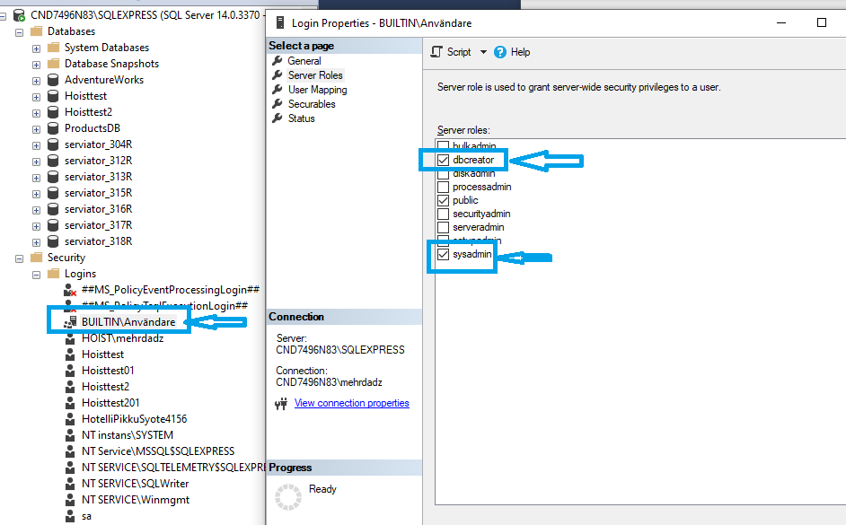

* Run again the **PM> Updae-Database**

This time the database: ProductsDB shall be created as shown in the SSMS:

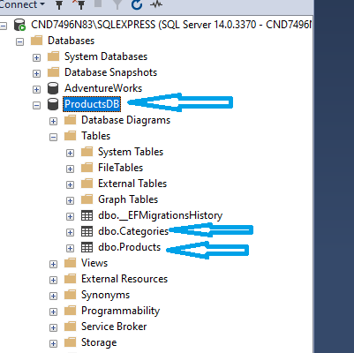

Testing with post man you should use as following formats :

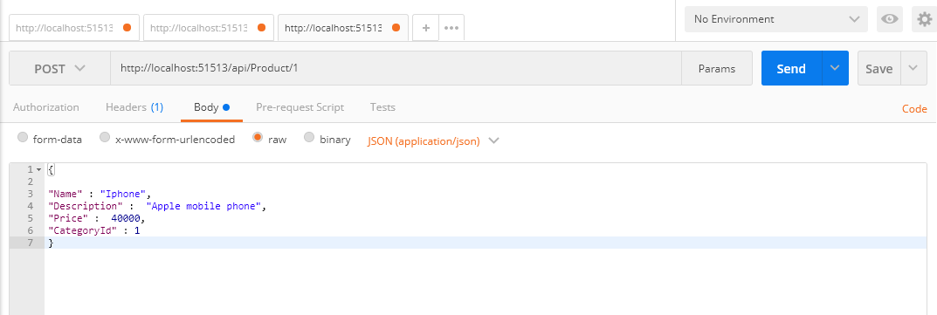

Use “Name ” : “Iphone” NOT Name : “Iphone”

This project with using of VS and runing with IIS Express going fine.

But with Runing with docker has follwoing problem with connection to the database:

System.InvalidOperationException

HResult=0x80131509

Message=An exception has been raised that is likely due to a transient failure. Consider enabling transient error resiliency by adding 'EnableRetryOnFailure()' to the 'UseSqlServer' call.

Source=Microsoft.EntityFrameworkCore.SqlServer

Inner Exception 1:

SqlException: A network-related or instance-specific error occurred while establishing a connection to SQL Server. The server was not found or was not accessible. Verify that the instance name is correct and that SQL Server is configured to allow remote connections. (provider: TCP Provider, error: 0 - A connection attempt failed because the connected party did not properly respond after a period of time, or established connection failed because connected host has failed to respond.)

Inner Exception 2:

Win32Exception: A connection attempt failed because the connected party did not properly respond after a period of time, or established connection failed because connected host has failed to respond.